All Saints Day Activity

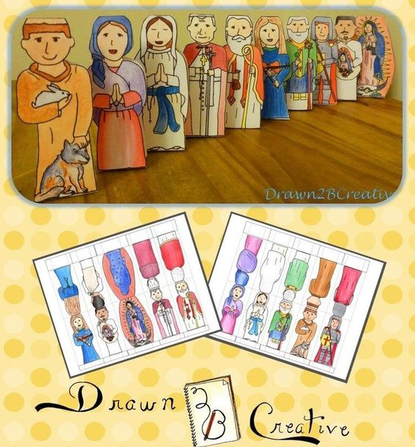
“Saints on our side” - Come and celebrate All Saints’ Day with us – Select your favourite saint and colour his/her picture or write his/her short biography. Bring your work (coloured picture/biography of your favourite saint) to our church on Sunday and place it in front of the altar. Following Mass, you will receive some sweets... Celebrate, not Halloween, this year, but All Saints’ Day; and pray that your patron saint intercedes for you!
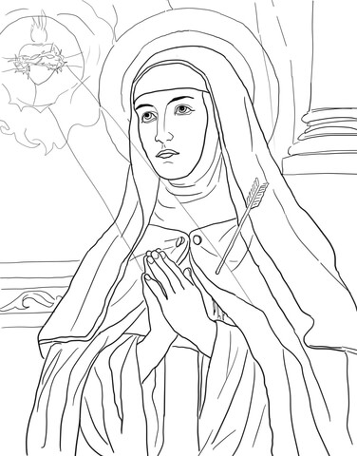

Learn a bit more about saints
The Saints Are Models of Holiness
The Church honours people like Mary and the saints because they responded to God’s grace working within them, so they were able to do amazing things and inspire people to know and to serve God more deeply. Why do you think the Church wants us to know about the saints? (The saints can inspire us and provide good examples of how to follow Jesus.) The Church gives them the official title of “saint” to let us know that these are people who show us how to live as Christians. Saints are people whom you and I can turn to for inspiration, advice, and help in our everyday lives.
The Saints Are People Too
You may be thinking to yourself, “Sure, the saints are special. But there’s no way I could be super holy like them.” Remember: The saints are not superhuman; they are real people. They grew up like we did, in good circumstances and in bad. They had families and friends, went to school and worked. Some saints were nuns or priests; others were married or single. Some were young, and others were old. We may think the saints were perfect, but they weren’t. They were just like us. Sometimes they sinned, and sometimes they failed. Some saints were even people who were hard to get along with. But they believed in God’s forgiveness and kept trying to do God’s will. They gave their whole heart and life to God even when it was difficult to follow Jesus.
God Wants Us to Be Saints
God wants all of us to be saints. You may be wondering “Exactly how do we do that?” Thanks to Baptism, we are given the most important element to becoming a saint: God’s grace. With God’s grace, we can make choices that will cause us to be spiritually stronger and healthier and that bring us closer to God. We also have the Bible, the very Word of God, to guide us and to help us follow Jesus. But sometimes, it helps to have a few pointers to see how grace and the Gospel can help us in our everyday life.
We Are a Part of the Communion of Saints
That’s where the saints come in. We can turn to them for help. Think of it this way—in life, we are like runners in a long race. Runners don’t run alone, do they? They have coaches who teach them how to be strong and healthy, they have friends who cheer them on, they have other runners who inspire them and give them good advice. Just as runners aren’t alone in their race, neither are we. We have God and the whole Communion of Saints by our sides. The saints knew that Jesus had shown us what is good, and they used the Gospels as their guide. They made it a habit to be tuned into God in all that they did. In the long race of their lives, the saints also had certain spiritual exercises to stay spiritually fit. They prayed often and worked hard for God. The saints knew that they were God’s hands on earth, helping others, even though they might find themselves in tough situations.

